Pearl Plate Restaurant Website Proposal


Session 2025 - 2029

Submitted by
Group 10
Group Members:
Syeda Qummera Abubakar (2025-CS-324)
Fatima Ijaz(2025-CS-324)
Minahil shabbir(2025-CS-324)

Supervised by:
Prof. Ashir Kamal

Course:
CSC-100L Application of Information and Communication Technologies
Department of Computer Science
University of Engineering and Technology Lahore,Pakistan

1. Introduction
Pearl Plate is a luxury restaurant website, a group project, designed to showcase a premium Pakistani dining experience. The website is built using HTML5 and CSS3 only, focusing on clean structure, modern visuals, smooth scrolling, and user-friendly navigation. The design emphasizes elegance, tradition, and professionalism.
2. Objectives of the Website
- Present Pearl Plate as a high-end luxury restaurant
- Highlight services such as fine dining, events, and delivery
- Provide clear navigation across sections
- Allow users to contact or book events easily
- Create a visually appealing and responsive layout

Overview of the Project:

· Purpose: create an engaging and effective online platform for the restaurant business
· Importance: crucial for a strong online presence, especially in the competitive restaurant industry
· Goal: capture the essence of the restaurant by showcasing the menu, atmosphere, and unique dining experience
· Function: primary point of contact for potential customers
· Design focus: make the website visually appealing, easy to navigate, and informative
· Ultimate aim: drive more customers to visit the restaurant
· Target audience: local residents, tourists, and food enthusiasts seeking new dining experiences
· Teamwork: responsibilities divided among team members to ensure objectives are met and the project is completed on time

Website Structure and Content:
The website was designed to be both visually appealing and highly functional. It follows a simple, yet professional structure to ensure that visitors can easily find the information they are looking for. The core pages of the website are as follows:

1. Home Page

2. About Us Page
3. Services Page

4. Contact Us Page

3. Technologies Used
HTML: Structure and content
CSS: Styling, layout, animations, and responsiveness
Google Fonts: Typography (Great Vibes & Montserrat)

4. File Structure
- index.html → Main website structure
- style.css → Styling and layout rules

- Image assets (used via CSS):
  - hero-bg.jpg
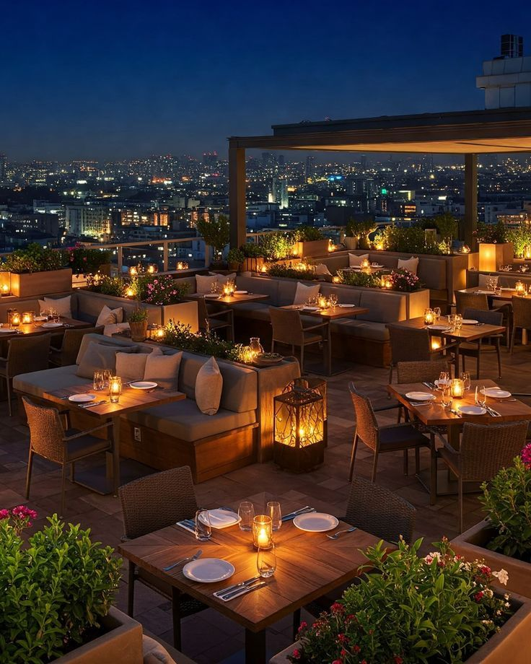
  - about-bg.jpg
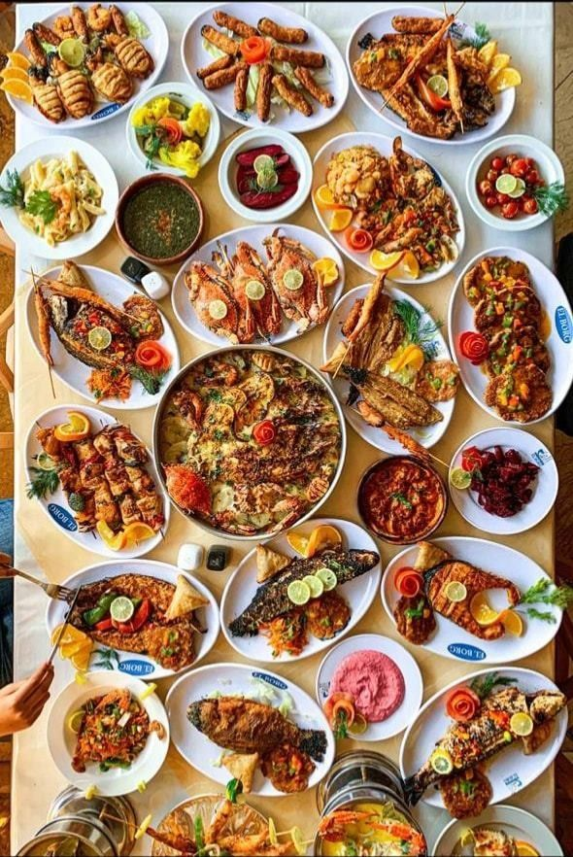

  - fine-dining.jpg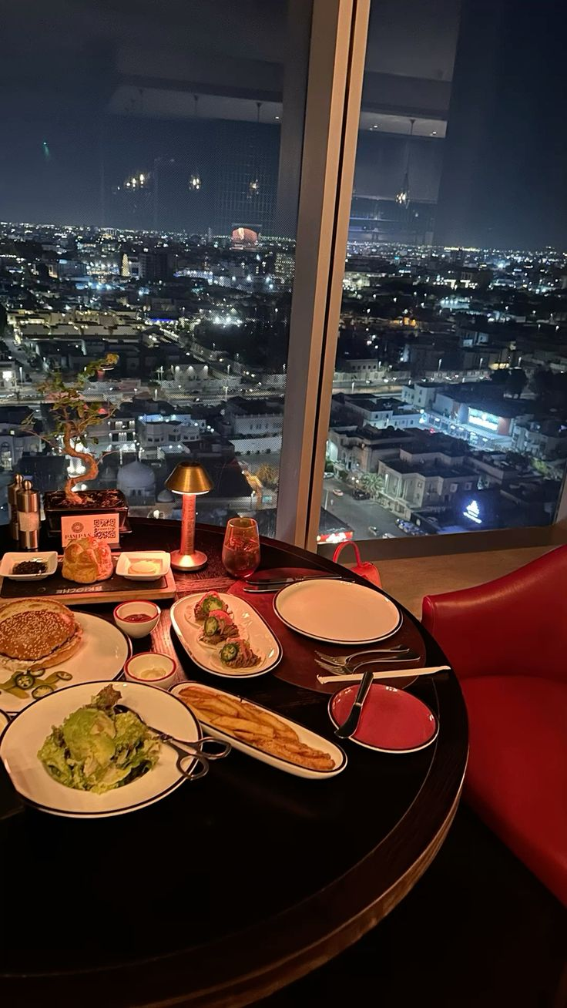

  - events.jpg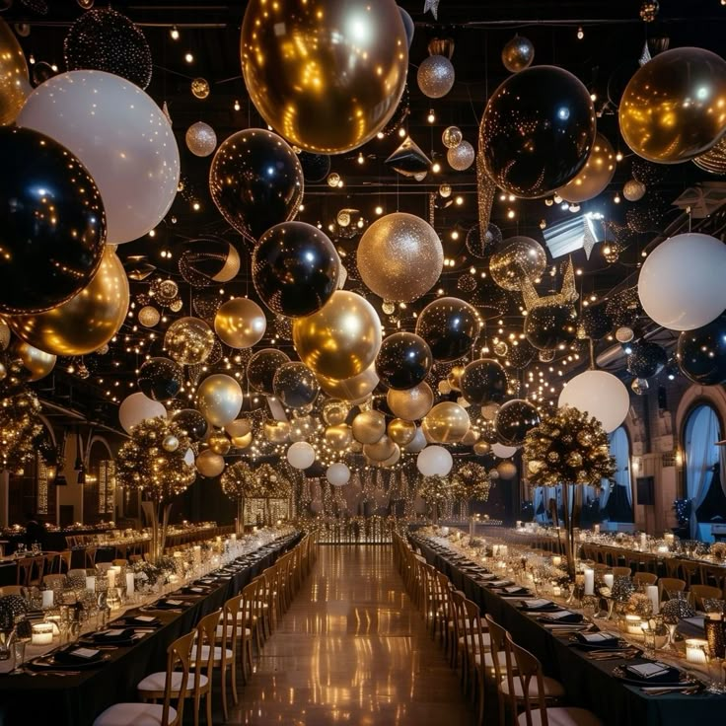

  - delivery.jpg


5. HTML File Explanation

5.1 Document Setup
- <!DOCTYPE html> defines HTML
- <meta charset="UTF-8"> ensures character compatibility
- <meta name="viewport"> enables responsive design
- External Google Fonts and CSS file are linked in <head>

5.2 Navigation Bar (<nav>)
- Fixed navigation bar at the top
- Contains:
  - Website logo (PEARL PLATE)
  - Navigation links (Home, About, Services, Contact)
- Uses anchor links for smooth scrolling to sections
Purpose: - Easy navigation - Always accessible due to fixed position

5.3 Home Section (#home)
- Full screen hero section
- Includes:
  - Restaurant name in decorative font
  - Tagline text
  - Call-to-action button (Book a Table)
Purpose: - First impression - Brand identity - Encourage user interaction

5.4 About Section (#about)
- Overlay-based section with background image
- Includes:
  - Section title: “Our Story”
  - Short tagline
  - Vision paragraph describing restaurant philosophy

Feature Icons (Circles):
- Fresh Food
- Top Chefs
- 24/7 Service
- Royal Taste
Each icon rotates on hover to enhance interactivity.
Purpose: - Build trust - Share brand story - Highlight strengths

5.5 Services Section (#services)
- Card-based layout
- Three service cards:
  - Fine Dining
  - Special Events
  - Free Delivery
Each card includes: - Background image - Title - Short description
Purpose: - Clearly explain offerings - Visual engagement

5.6 Contact Section (#contact)
- Simple contact form
- Input fields:
  - Full Name
  - Email Address
  - Event Type (dropdown)
  - Message box
- Submit button
Purpose: - User communication - Event booking requests

5.7 Footer
- Displays copyright information
- Reinforces brand identity

6. CSS Styling Explanation

6.1 Global Styles
- Resets default margins and padding
- Applies Montserrat font globally
- Enables smooth scrolling
- Sets yellow-black color theme

6.2 Navigation Styling
- Flexbox used for alignment
- Fixed positioning with high z-index
- Hover effects on links

6.3 Section Layout (.full-page)
- Each section occupies full viewport height
- Centered content using flexbox
- Consistent spacing and alignment

6.4 Home Section Styling
- Background image with yellow overlay
- Large decorative logo font
- Button with hover transition

6.5 About Section Styling
- Dark overlay for readability
- Circular icons with hover rotation (360 degrees)
- Smooth transition effects

6.6 Services Cards Styling
- Card layout using flexbox
- Hover lift animation
- Background images set via CSS classes

6.7 Contact Form Styling
- Clean input fields
- Bold submit button
- Hover effect on button

6.8 Footer Styling
- Dark background
- Centered white text

7. Database Integration (SQL)
The Pearl Plate project also includes a simple SQL database to manage backend restaurant operations such as menu items, event bookings, and customer inquiries.

Database Tables
- MenuItems: Stores dish details (ItemID, ItemName, Price, Category)
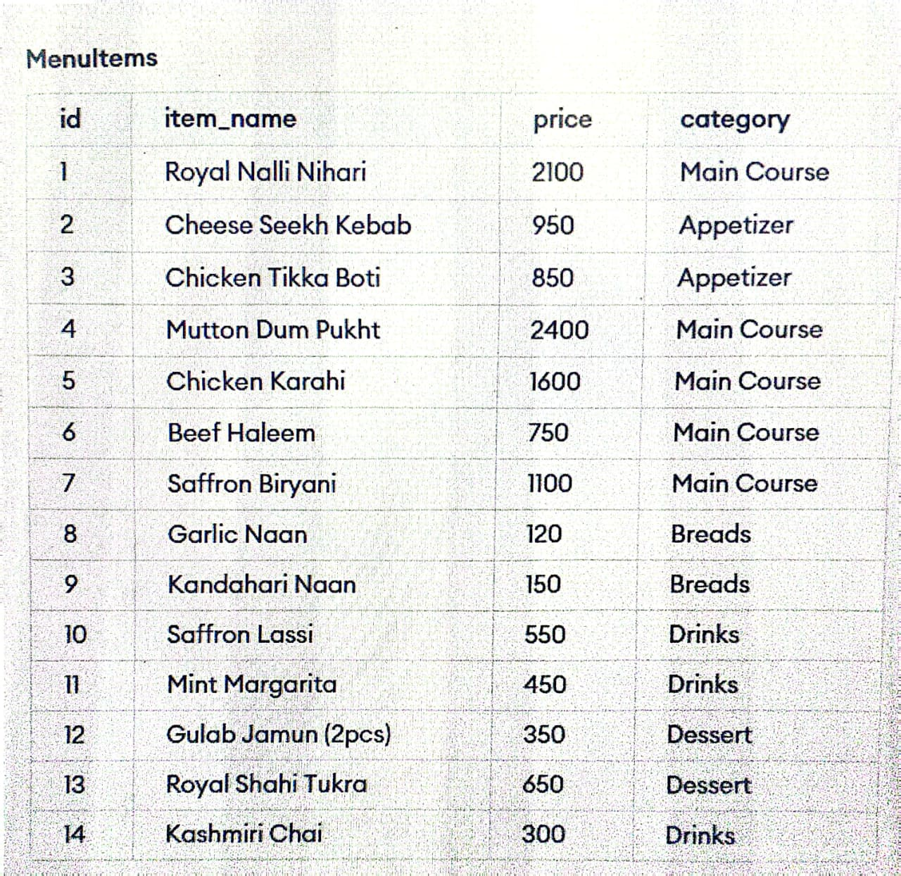
- SpecialEvents: Stores event bookings (EventID, EventType, CustomerName, EventDate)
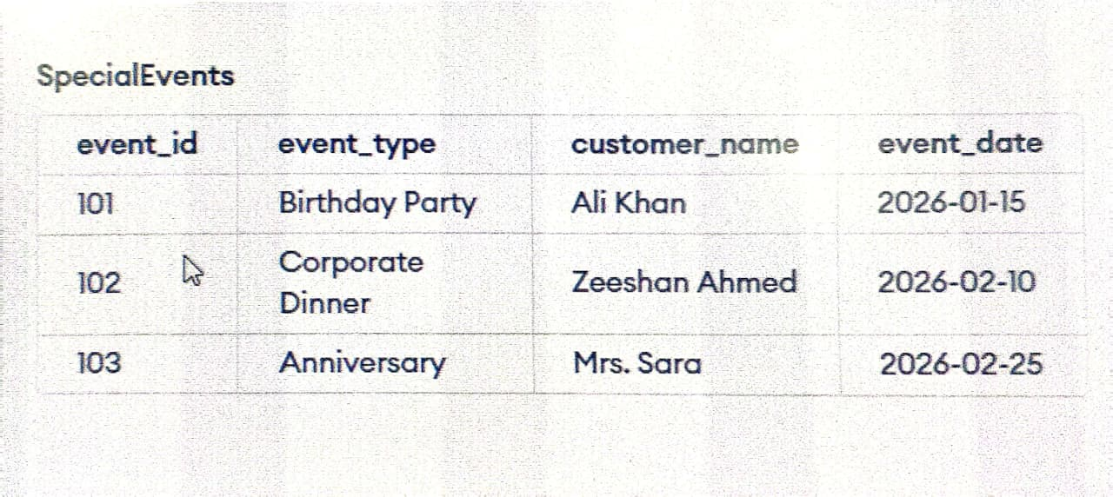
- ContactInquiries: Stores customer messages (InquiryID, CustomerEmail, Message)
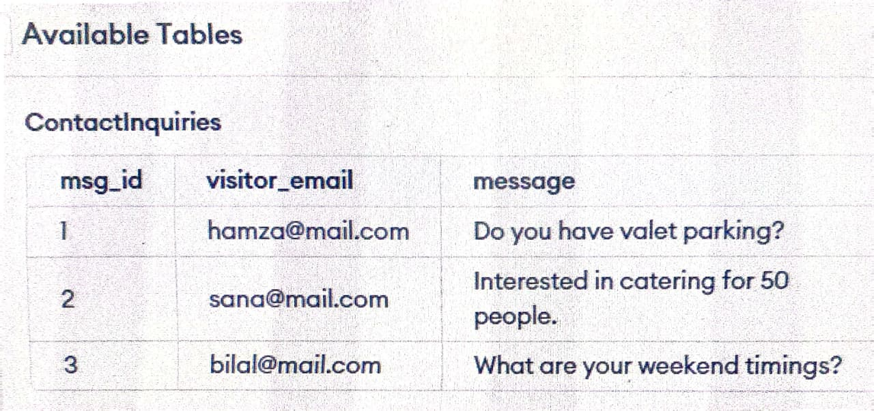

Core Functionalities
- Pre-filled with sample data (menu items, events, inquiries)
- Supports price updates using UPDATE queries
- Allows menu item removal using DELETE queries
- Uses SELECT queries for reporting and data viewing

8. Responsiveness
- Flexible widths and flexbox layouts
- Font sizes adapt using clamp()
- Works across desktops, tablets, and mobiles

9. User Experience (UX) Features
- Smooth scrolling navigation
- Hover animations for engagement
- Clear call-to-action buttons
- Simple and readable layout

10. Limitations
- No backend integration
- Form does not submit data
- Images must be added manually
- No JavaScript functionality

11. Future Enhancements
- Add JavaScript for form validation
- Connect contact form to backend/database
- Add online reservation system
- Improve accessibility
- Add animations using JavaScript or libraries

Conclusion
Pearl Plate is a fully functional static website that effectively represents a luxury restaurant brand. With strong visual design, clean structure, and modern styling, it serves as an excellent foundation for future development and real-world deployment.

